**SQL Project**

**Q1.1**

Use Northwind

SELECT CustomerID,CompanyName, Address + ',' + City+','+PostalCode+','+Country AS 'Address'

FROM Customers Where City = 'Paris' OR City = 'London';

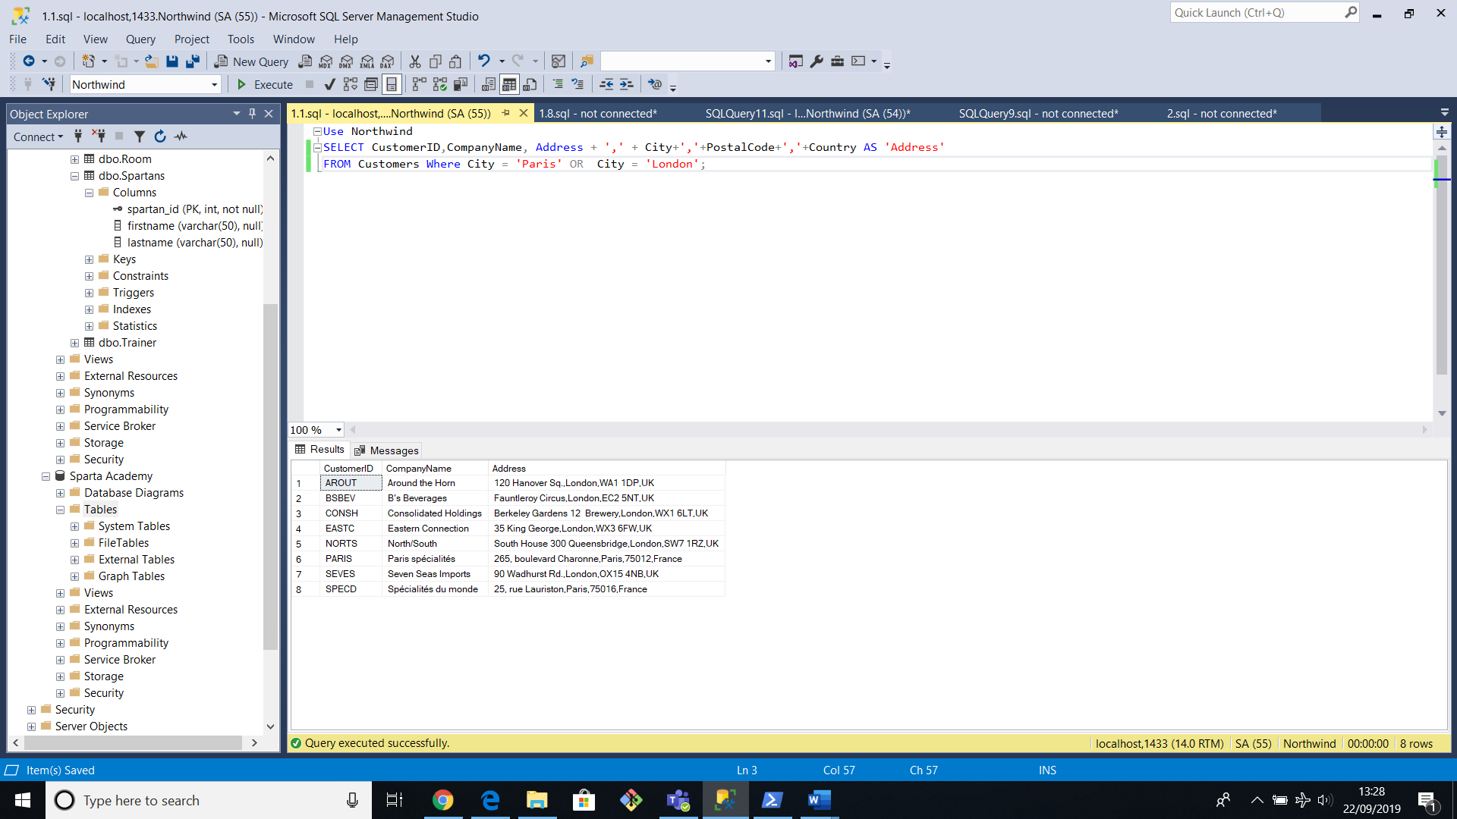

**1.2**

Use Northwind

SELECT *

FROM Products Where QuantityPerUnit LIKE '%bottle%' ;

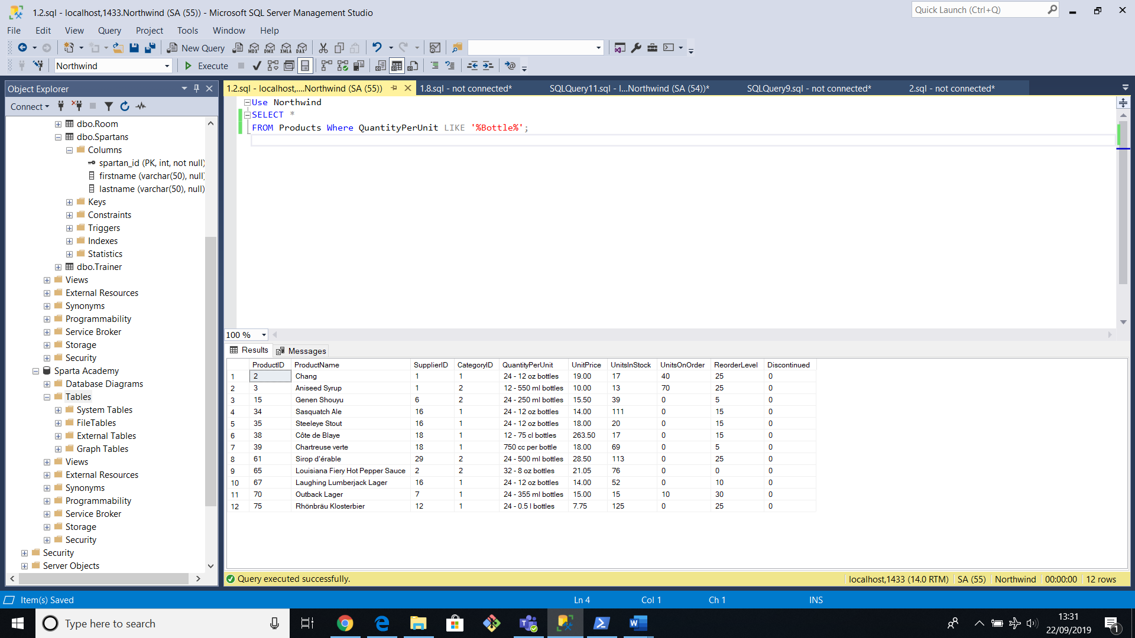

**1.3**

SELECT ProductName,CompanyName,Country,QuantityPerUnit

From Products

join Suppliers s ON s.SupplierID=Products.SupplierID

Where QuantityPerUnit LIKE '%bottle%' ;

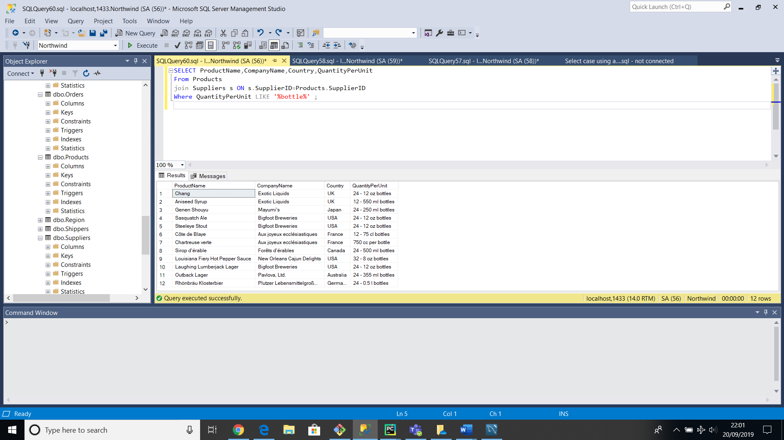

**1.4**

use Northwind

SELECT c.CategoryName, c.CategoryID,COUNT(ProductName) AS 'No.of Products'

FROM Products p

Join Categories c ON p.CategoryID=c.CategoryID

GROUP BY c.CategoryID, c.CategoryName

ORDER BY COUNT (ProductName) DESC;

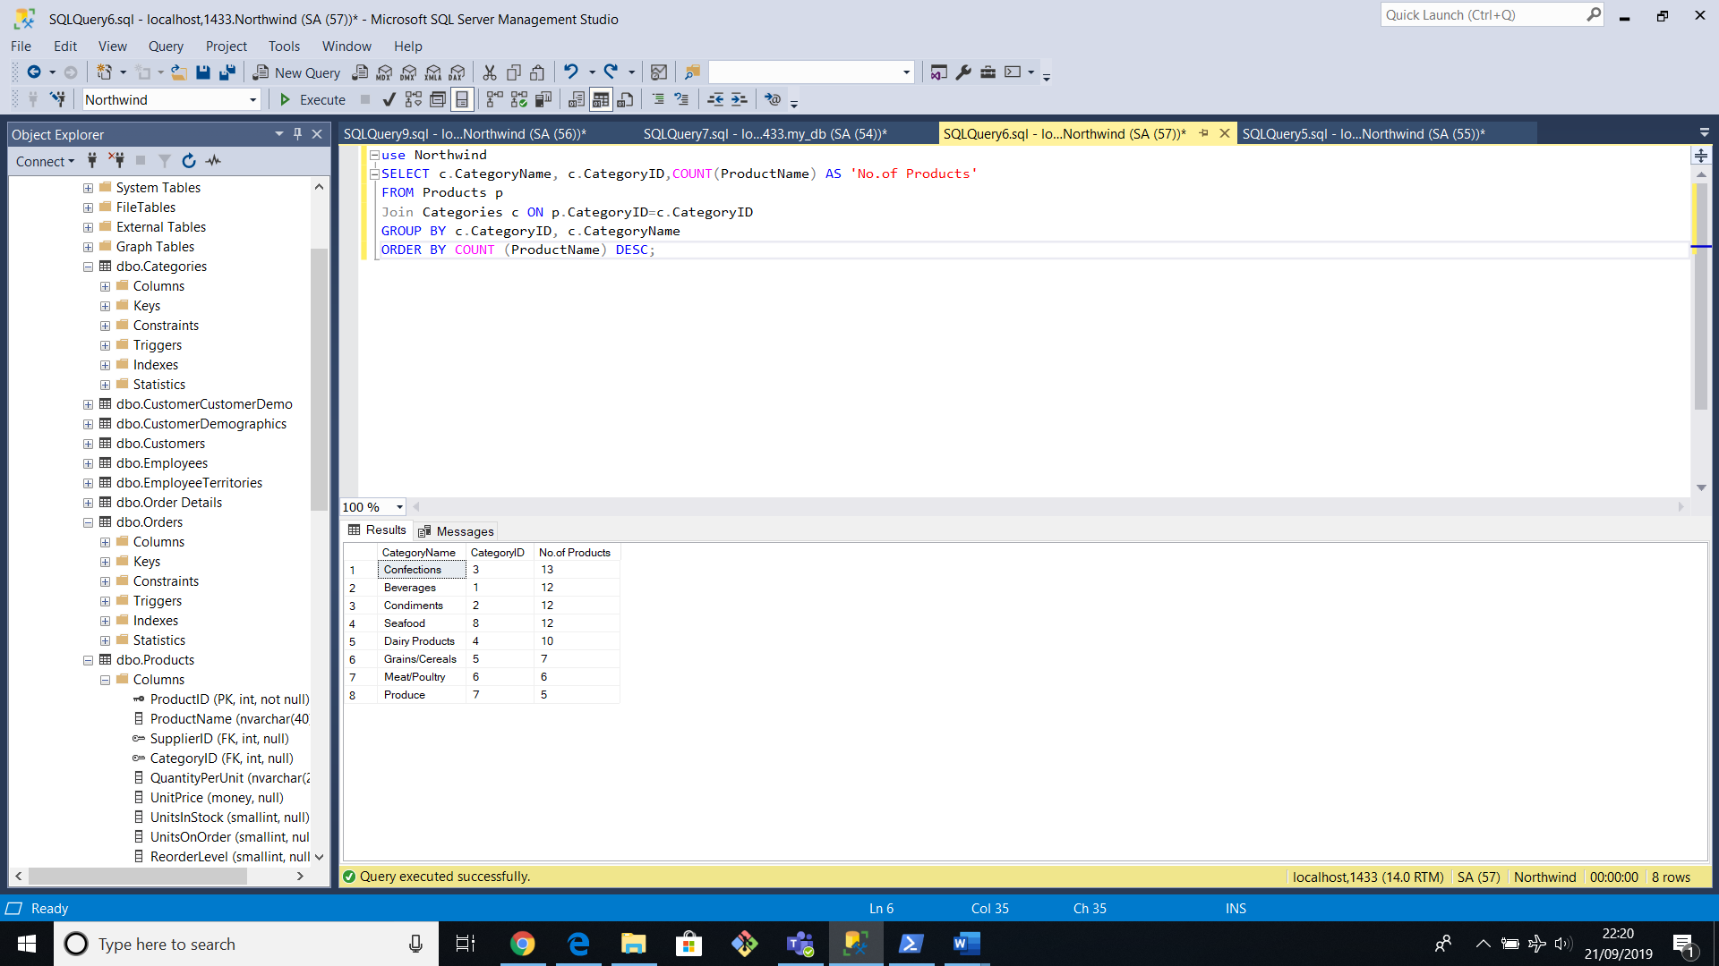

**1.5**

SELECT TitleOfCourtesy +' '+ FirstName +' '+ lastname AS 'FullName' , City

FROM employees WHERE country = 'UK';

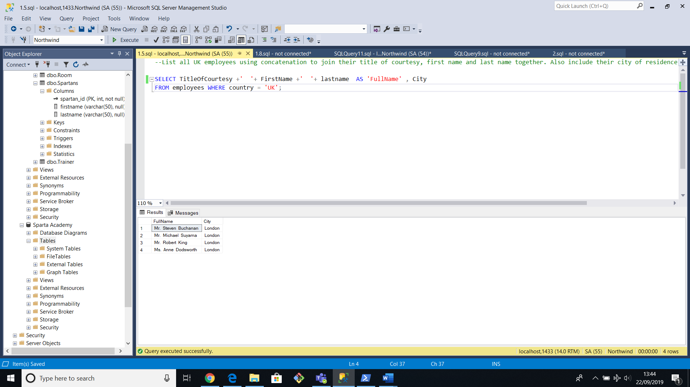

**1.6**

USE Northwind

--SELECT * From Territories t

--SELECT * FROM REGION

SELECT * FROM [Order Details] od

JOIN Products p on od.ProductID = p.ProductID

--join region r on t.RegionID= r.RegionID

--SUM (od.UnitPrice * od.Quantity) AS 'total sales'

where od.UnitPrice * od.Quantity*(1-Discount)> 10000

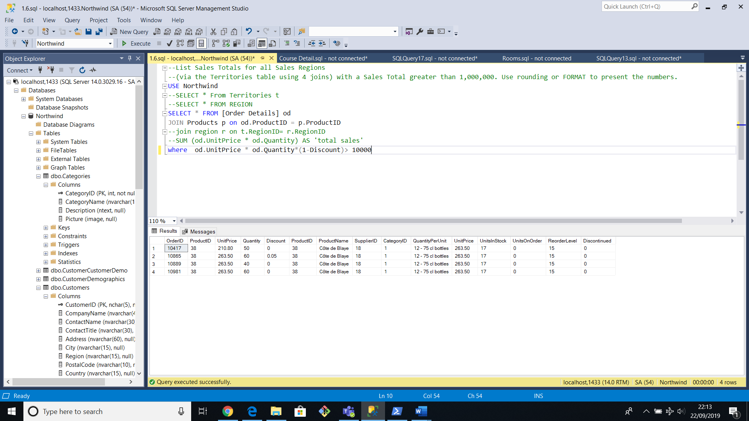

**1.7**

use Northwind

SELECT count(*) AS 'No. of Orders with freight amount greater than 100'

FROM Orders

WHERE Freight >100 AND ShipCountry = 'USA' OR ShipCountry = 'UK';

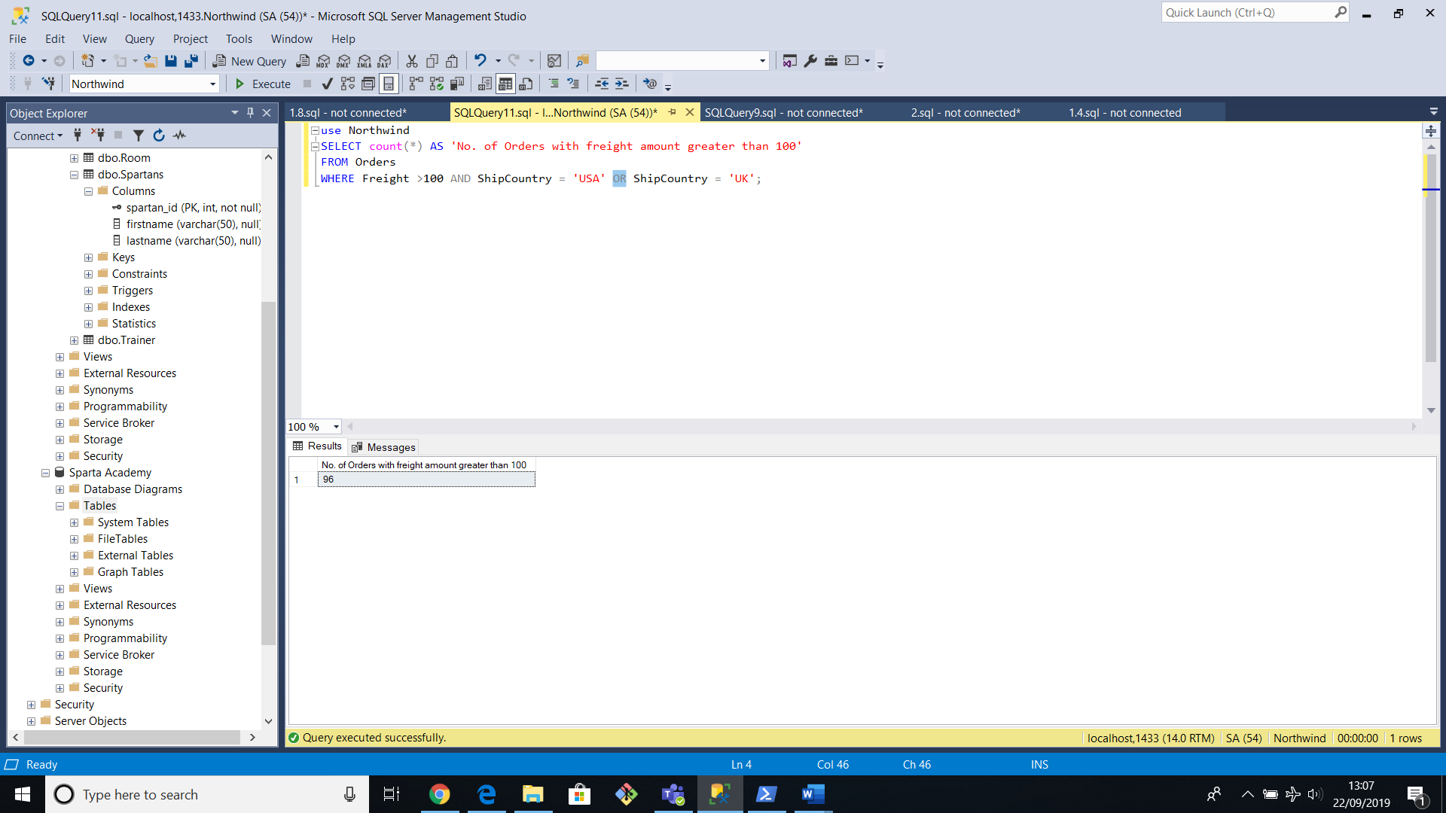

**1.8**

use Northwind

SELECT TOP 1 * FROM [Order Details]

ORDER BY Discount*UnitPrice DESC;

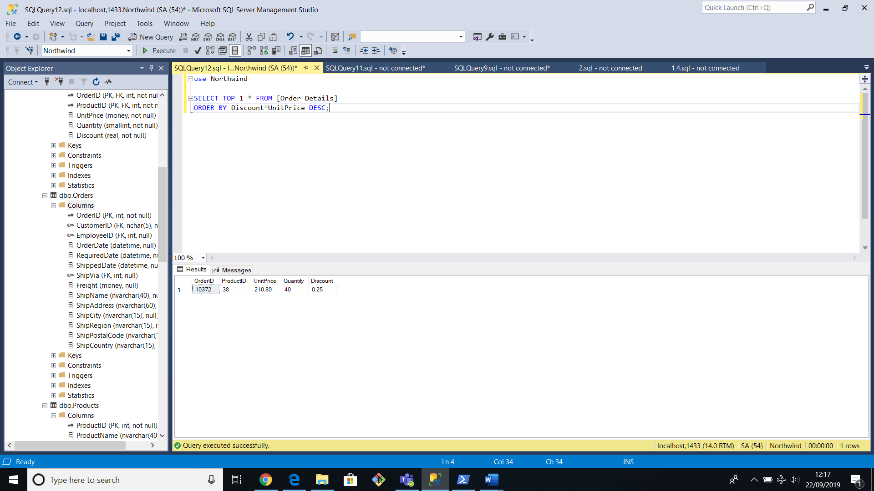

**2.2**

USE [Sparta Academy ]

CREATE TABLE Spartans

(

spartan_id int NOT NULL PRIMARY KEY,

[First Name] VARCHAR(30),

[Last Name] VARCHAR(30),

)

CREATE TABLE Trainer

(

Trainer_id int NOT NULL PRIMARY KEY,

[First Name] VARCHAR(30),

[Last Name] VARCHAR(30),

)

CREATE TABLE Academy

(

academy_id int NOT NULL PRIMARY KEY,

[Academy Name] VARCHAR(30) Not NULL Unique,

)

CREATE TABLE Streams

(

stream_id int NOT NULL PRIMARY KEY,

[Stream Name] VARCHAR(30),

[Stream Duration In Weeks] INT,

)

CREATE TABLE Rooms

(

Room_id int NOT NULL PRIMARY KEY,

academy_id int,

[Room Name] VARCHAR(30),

)

CREATE TABLE [Course Detail]

(

course_id int NOT NULL PRIMARY KEY,

stream_id int,

academy_id int,

Room_id int,

[Start Date] DATE,

[End Date] DATE,

);

**2.3 Spartan table**

use [Sparta Academy ]

INSERT INTO Spartans (spartan_id, [First Name], [Last Name])

VALUES ('1', 'Adam', 'Smith');

INSERT INTO Spartans (spartan_id, [First Name], [Last Name])

VALUES ('2', 'John', 'Williams');

INSERT INTO Spartans (spartan_id, [First Name], [Last Name])

VALUES ('3', 'Nick', 'Willis');

INSERT INTO Spartans (spartan_id, [First Name], [Last Name])

VALUES ('4', 'Jenny', 'Jones');

INSERT INTO Spartans (spartan_id, [First Name], [Last Name])

VALUES ('5', 'Katie', 'Prince');

INSERT INTO Spartans (spartan_id, [First Name], [Last Name])

VALUES ('6', 'Peter', 'Brown');

INSERT INTO Spartans (spartan_id, [First Name], [Last Name])

VALUES ('7', 'Mo', 'Khan');

INSERT INTO Spartans (spartan_id, [First Name], [Last Name])

VALUES ('8', 'Juan', 'Carlos');

INSERT INTO Spartans (spartan_id, [First Name], [Last Name])

VALUES ('9', 'Jan', 'Miller');

INSERT INTO Spartans (spartan_id, [First Name], [Last Name])

VALUES ('10', 'Kyle', 'Carpenter');

INSERT INTO Spartans (spartan_id, [First Name], [Last Name])

VALUES ('11', 'Alvarao', 'Carlos');

INSERT INTO Spartans (spartan_id, [First Name], [Last Name])

VALUES ('12', 'Margate', 'Baker');

INSERT INTO Spartans (spartan_id, [First Name], [Last Name])

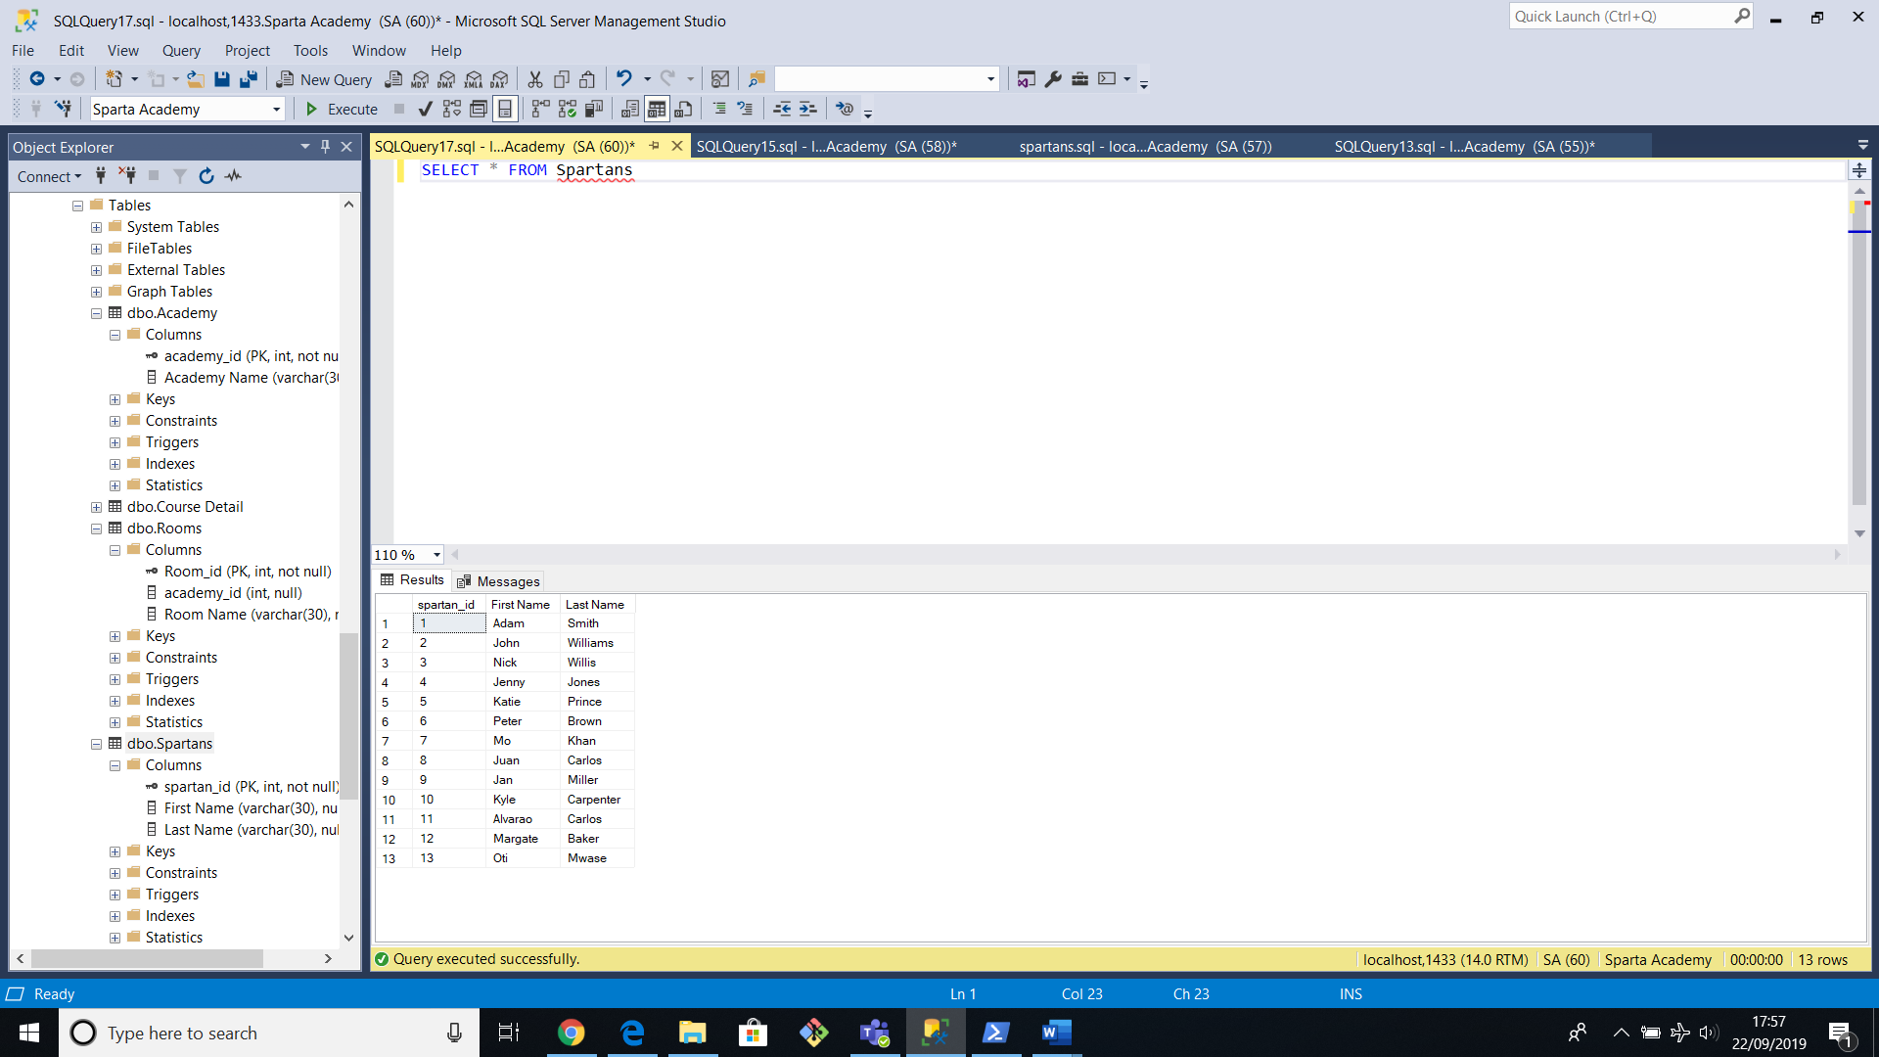VALUES ('13', 'Oti', 'Mwase');

**Trainer table**

INSERT INTO trainer (trainer_id, [First Name], [Last Name])

VALUES ('1', 'Tim', 'Cawte');

INSERT INTO trainer (trainer_id, [First Name], [Last Name])

VALUES ('2', 'Richard', 'Gurney');

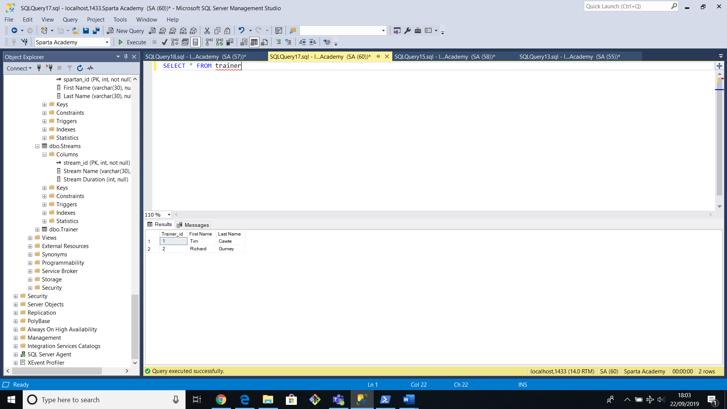

**Academy table**

INSERT INTO academy (academy_id, [Academy Name])

VALUES ('1', 'Richmond');

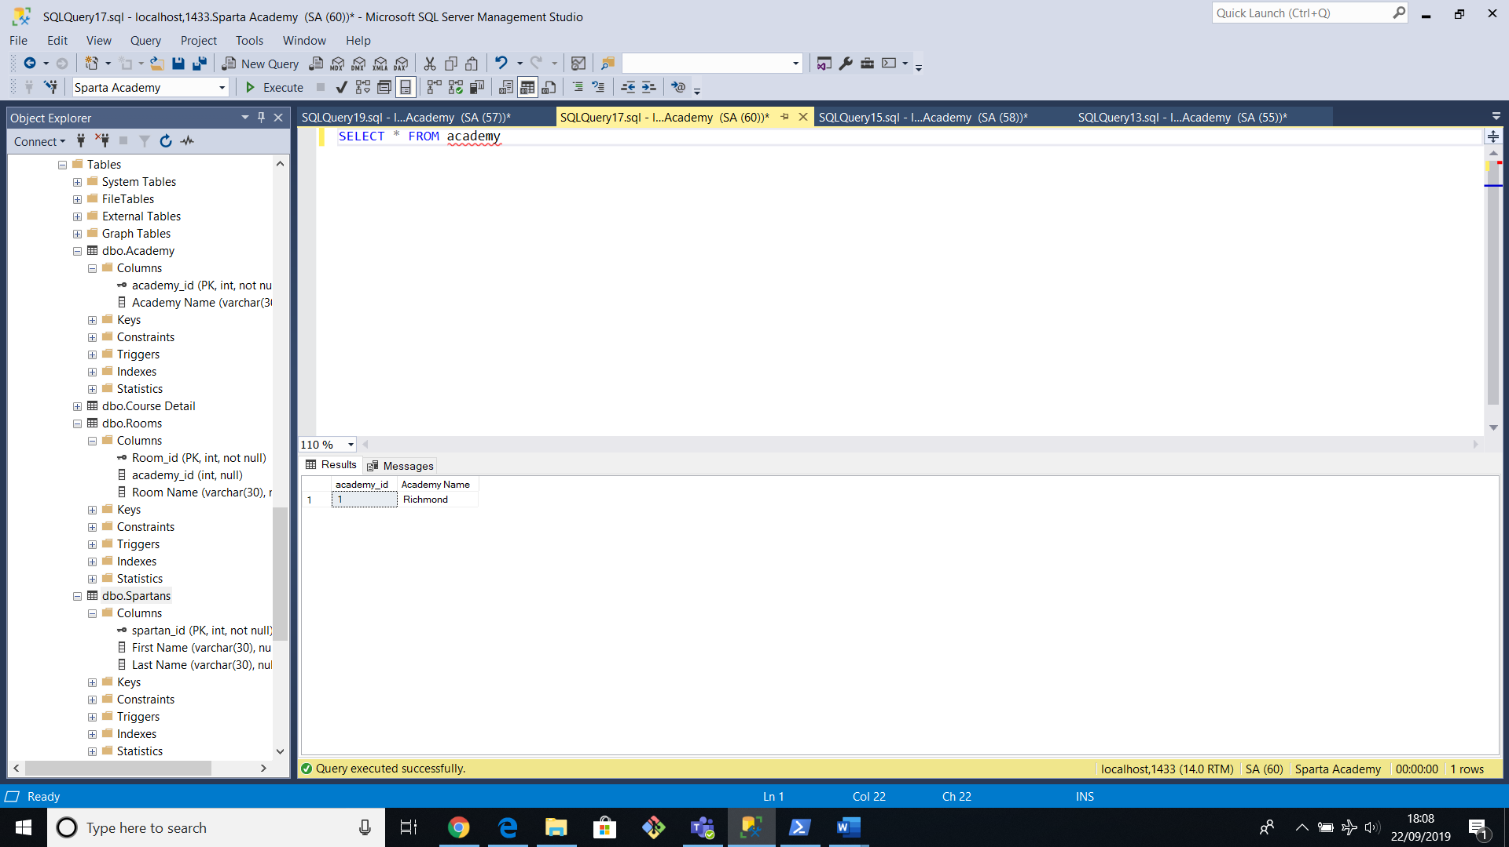

**Stream table**

INSERT INTO streams (stream_id, [Stream Name], [Stream Duration In Weeks])

VALUES ('1', 'BA-Test', '7');

INSERT INTO streams (stream_id, [Stream Name], [Stream Duration In Weeks])

VALUES ('2', 'Engineering', '6');

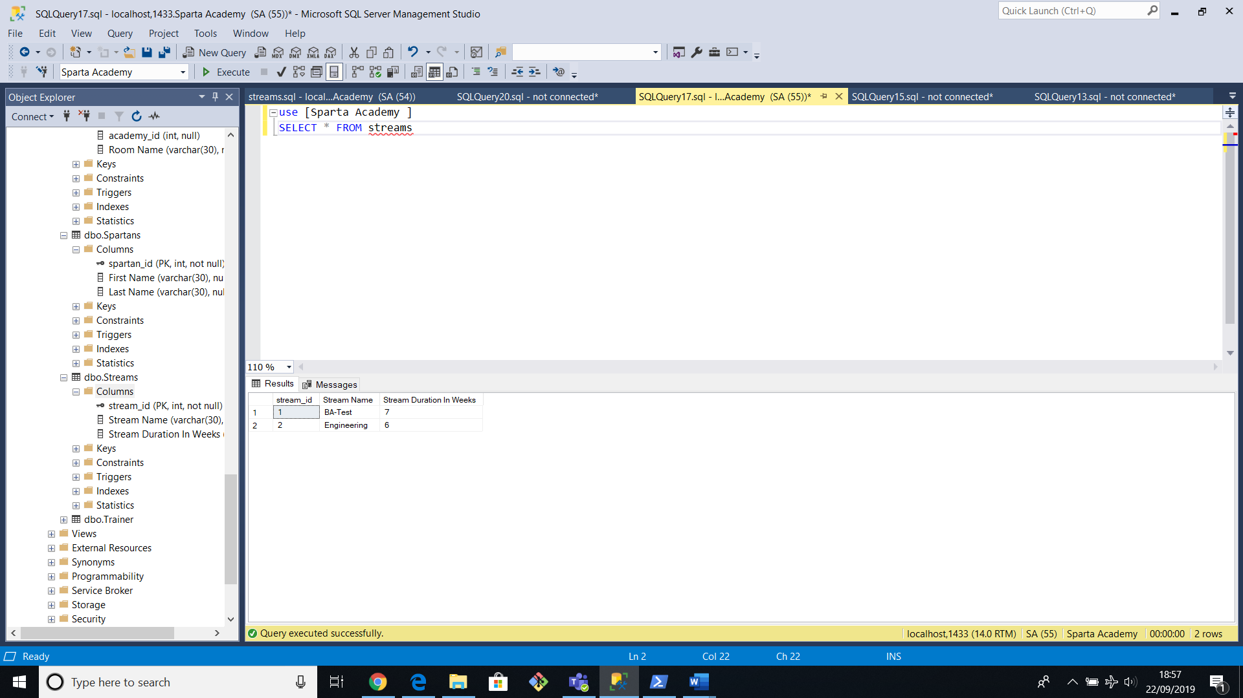

**Rooms Table**

Use [Sparta Academy ]

INSERT INTO Rooms(Room_id, academy_id, [Room Name])

VALUES ('1', '1', 'Room 1');

INSERT INTO Rooms(Room_id, academy_id, [Room Name])

VALUES ('2', '1', 'Room 3');

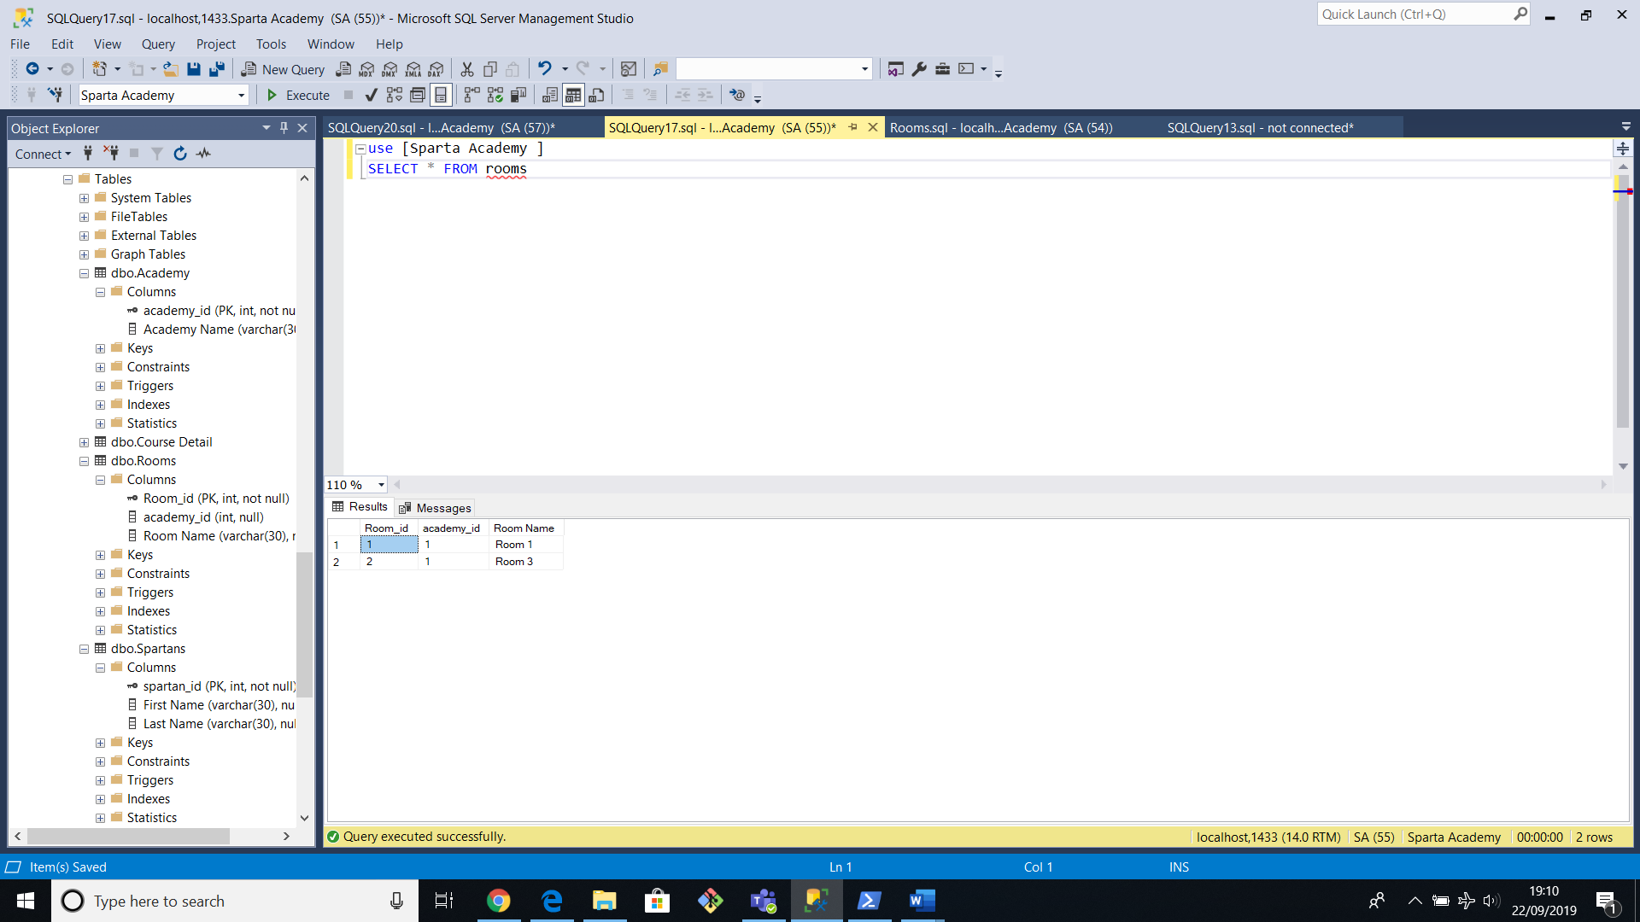

**Course Detail Table**

INSERT INTO [Course Detail] (course_id, Stream_id, academy_id, Room_id, [Start Date], [End Date])

VALUES ('1','1', '1', '1', ' 2018-01-15', '2018-03-02');

INSERT INTO [Course Detail] (course_id,Stream_id, academy_id, Room_id, [Start Date], [End Date])

VALUES ('2','2', '1', '2', '2018-01-22' , '2018-03-03 ');

